**Description**:

Text Wrapper wrap a static text string (Statement) along with a dynamic text field value which was taken as an input from the dataset. This dynamic field value will update according to the selected filter/slicer keeping the static text intact. The static string needs to be provided by the user which will be appended as “ : <<Static String>>” after the dynamic field value in the visual resulting the final value in the visual as:

“<<Dynamic Value>> : <<Static Value>>”

How to use visual:

1. Prepare text data field as per the requirement
2. Load data and load text wrapper visual.
3. Chart will load using the default settings. If the input data field has no specific value selected, it will render with the text “No question selected”



1. Add the input data field used in the text wrapper visual as a slicer/filter on the report and select a value in that slicer/filter. The “No question selected” text will now update to the text of the selected field



1. To add a static text after this field, go to the “Format” section and find the option “Text settings”

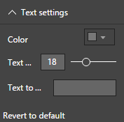

* 1. Input the static text In the third option “Text to..” field which will display additionally to the input data field in step 4

 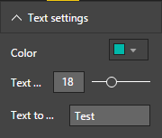

1. We can change the color of the text using the “color” option under “Text settings” option in the “format” pane

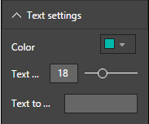

Blog:

Text wrapper tool provides the option to show the visual titles based on the dynamic (filtered) and static data combination. Many times we need to display the text data from the datasets which can be filtered using either the slicers or filters and some static text appended to the dynamic text. This is the sole purpose of the existence of this text wrapper visual.

**Example:**

We need to display a text like “What is your job location? : ROW (Outside US)” in our report. The text “What is your job location?” is dynamic based on a question text data field but the text “ : ROW (Outside US)” is static.

|  |  |
| --- | --- |
| **Before (Without using Text Wrapper)** | **After (Using Text Wrapper)** |
| We have a slicer of the question text field on changing which the above text needs to be update. Previously to achieve this scenario, we need to use two visuals one dynamic and other static and align them together in the report as per the requirements. A drawback in this scenario is that we cannot ensure the proper spacing between the dynamic and static text since the question text length can vary and sometimes it can overlap the static text as well. | We Don’t need to worry about the drawbacks of the previous approach. This visual will append the text at the end of the dynamic field text and hence will ensure that no overlapping will happen between dynamic and static text and will maintain proper spacing between the dynamic and static strings. |

Do you have any thoughts or feedback on Text Wrapper? Please comment below!